CTE Program Narrative

NAME OF COLLEGE: San Joaquin Delta College
CONTACT: Steven McCarty
PHONE NUMBER: 209.954.5407
EMAIL ADDRESS: smccarty@deltacollege.edu
DATE: 9/9/2021
DIVISION: Business and Law TrAC, Applied Science, Business, and Technology (ASBT) Division
FACULTY: Steven McCarty, Chair/Professor Law Department
PROGRAM NAME: Real Estate Salesperson Certificate of Accomplishment
REASON FOR APPROVAL REQUEST (Check One):
☒ New Program Proposal
☐ Program Revision Proposal (Substantial or TOP Code Changes)
☐ Locally Approved

TYPE OF DEGREE:
☐ Certificate of Achievement
☐ Associate of Arts
☐ Associate of Science
☐ Associate of Arts for Transfer
☐ Associate of Science for Transfer
☒ Other

TRANSFER APPLICABILITY: Yes ☐ No ☐

ATTACHMENTS/INFORMATION REQUIRED:
Labor/Job Market Data and Analysis
Advisory Committee Meeting Minutes
List of Advisory Committee Members
Employer Survey, if applicable
- Statement of Program Goals and Objectives
Identify the goals and objectives of the program. For CTE programs, the statement must include the main competencies students will have achieved that are required for a specific occupation. The statement must, at a minimum, clearly indicate the specific occupations or fields the program will prepare students to enter and the basic occupational competencies students will acquire.
If the program is selective, describe relevant entry criteria and the selection process for admission to the program. Specify all mandatory fees that students will incur for the program aside from the ordinary course enrollment fee.
Prior to taking the California Real Estate Salesperson Examination, an applicant must complete three (3) college level courses specified by the California Department of Real Estate. Two of these classes are mandated: Real Estate Principles (BUSR 50) and Real Estate Practice (BUSR 52). The third class may be any real estate or real estate related course specified by The California Department of Real Estate. This Certificate of Accomplishment is designed to fulfill these course requirements while also introducing students to helpful skills and knowledge related to practicing as a salesperson, including professional selling, managing diversity and inclusion, and ethical leadership. Licensed Real Estate Salespersons work under the supervision of a licensed broker. Real Estate Salespersons are generally employed in real estate offices serving the general public; however, some agents secure employment with commercial enterprises operating in the real estate industry (e.g., developers, government agencies, escrow companies, loan officer, mortgage banker, property manager).

Upon successful completion of this program, students will be able to:
- Meet the requirements set by the State of California to qualify to take the Real Estate Sales licensing exam.
- Prepare the student to successfully pass the State of California Real Estate Sales licensing exam.
- Define the role, responsibility and ethical conduct of a licensed sales agent in California.
- Properly analyze how to acquire and hold real estate in California.

- Catalog Description
Enter exactly as it will appear in the catalog, including program outcomes. The description must also
- Convey the certificate’s goals(s) and objectives
- Provide an overview of the knowledge and skills that students who complete the requirements must demonstrate (student learning outcomes)
- List all prerequisite skills or enrollment limitations
- Mention any risks, such as occupations that are inherently competitive or low-salaried and/or occupational areas where inexperienced graduates are not generally hired.
- For CTE programs, the description must list the potential careers students may enter upon completion.
- Convey what the student may expect as an outcome

If applicable, reference accrediting and/or licensing standards. If there is a widely recognized certification provided by a professional association, specify whether the program will fully prepare completers for the recognized professional certification.
The purpose of this certificate is to help prepare a student to take the Real Estate Salesperson licensing examination. The courses listed in the Real Estate Salesperson Certificate of Accomplishment will qualify a student to take the written examination for a real estate salesperson license (see https://www.dre.ca.gov/examinees/requirementssales.html). Upon successfully passing the examination and other California Department of Real Estate (DRE) requirements, a license will need to be approved by the DRE. For additional information regarding the Real Estate Salesperson license, refer to http://www.dre.ca.gov. The license is required of individuals who conduct licensed real estate activities as described by Real Estate Law in California.

Licensed Real Estate Salespersons work under the supervision of a licensed broker. Real Estate Salespersons are generally employed in real estate offices serving the general public; however, some agents secure employment with commercial enterprises operating in the real estate industry (e.g., developers, government agencies, escrow companies, loan officer, mortgage banker, property manager). Students are encouraged to continue their real estate training by completing the requirements for the Real Estate Broker Certificate of Achievement and the Real Estate A.S. degree or Certificate of Achievement as well.

To earn a certificate of accomplishment, students must complete each of the required courses with a “C” grade or higher.

- Program Requirements
The program requirements must be consistent with the catalog description. The number of units, specific course requirements and the sequence of the courses must be coherent, complete and appropriate. Display the program requirements in a table format that includes all courses required for completion of the program (core requirements and required or restricted electives), subtotal of core units, and total program units. For each course, indicate the course department number, course title, and unit value.

Display of Program Requirements
Core Courses | Title | Units
BUS 40 | Real Estate Principles | 3
BUS 41 | Real Estate Practice | 3
 | Total Core Courses | 6

In addition to the core courses, the student must take at least 6 units from the following courses:

Elective Courses | Title | Units
BUS 18A | Business Law | 3
BUS 18B | Business Law | 3
BUS 42 | Real Estate Finance | 3
BUS 43 | Legal Aspects of Real Estate | 3
BUS 44 | Real Estate Appraisal | 3
BUS 45 | Real Estate Economics | 3
BUS 46 | Property Management | 3
 | In addition to 3 units from the above electives, students must take 3 units from the below list of electives
BUS 22 | Professional Selling | 3
BUS 32 | Managing Diversity and Inclusion | 3
LAW 25 | Ethics and Leadership | 3
 | Total Elective Courses | 6
Total Units Required for Certificate |  | 12

Display of Proposed Sequence

First Semester | Units |  | Second Semester | Units
BUS 40 | 3 |  | BUS 43 | 3
BUS 41 | 3 |  | LAW 25 | 3
Total | 6 |  | Total | 6
Third Semester | Units |  | Fourth Semester | Units
Total |  |  | Total

- Master Planning (Background and Rationale)
Given the stated goals and objectives, address the role the proposed program will fulfill in the college’s mission and curriculum offerings. This discussion may include some history of the program proposal origins, a description of the program purpose, and/or the program’s relevancy for the region and college.
The proposal must demonstrate a need for the program that meets the stated goals and objectives in the region the college proposes to serve with the certificate. A proposed new certificate must not cause undue competition with an existing program at another college.
If any expenditures for facilities, equipment or library and learning resources are planned, please explain the specific needs in this section.
If the program is to be offered in close cooperation with one or more specific employers, a discussion of the relationship must be provided.
In the San Joaquin Delta Community College District 2017 Comprehensive Master Plan, the district pointed out the following areas as “key” into the future:

● “Initiatives that foster professional growth and innovative service delivery,”
● “Community relationships with local educational institutions, employers, and workforce agencies that promote the region’s intellectual, social, economic, and cultural vitality,”
● “Career and technical programs that meet the labor market needs of employers in the region.”

The proposed Real Estate Salesperson Certificate of Achievement aligns with those values, specifically in the continued building of career advancement opportunities for residents of San Joaquin County, promotion of continue economic vitality, and meeting the labor needs of employers in our direct region and beyond (especially since all program courses are available online).

- Need for Program

  - Enrollment and Completer Projections
Address and justify the number of projected students or “annual completers” to be awarded the certificate each year after the program is fully established.
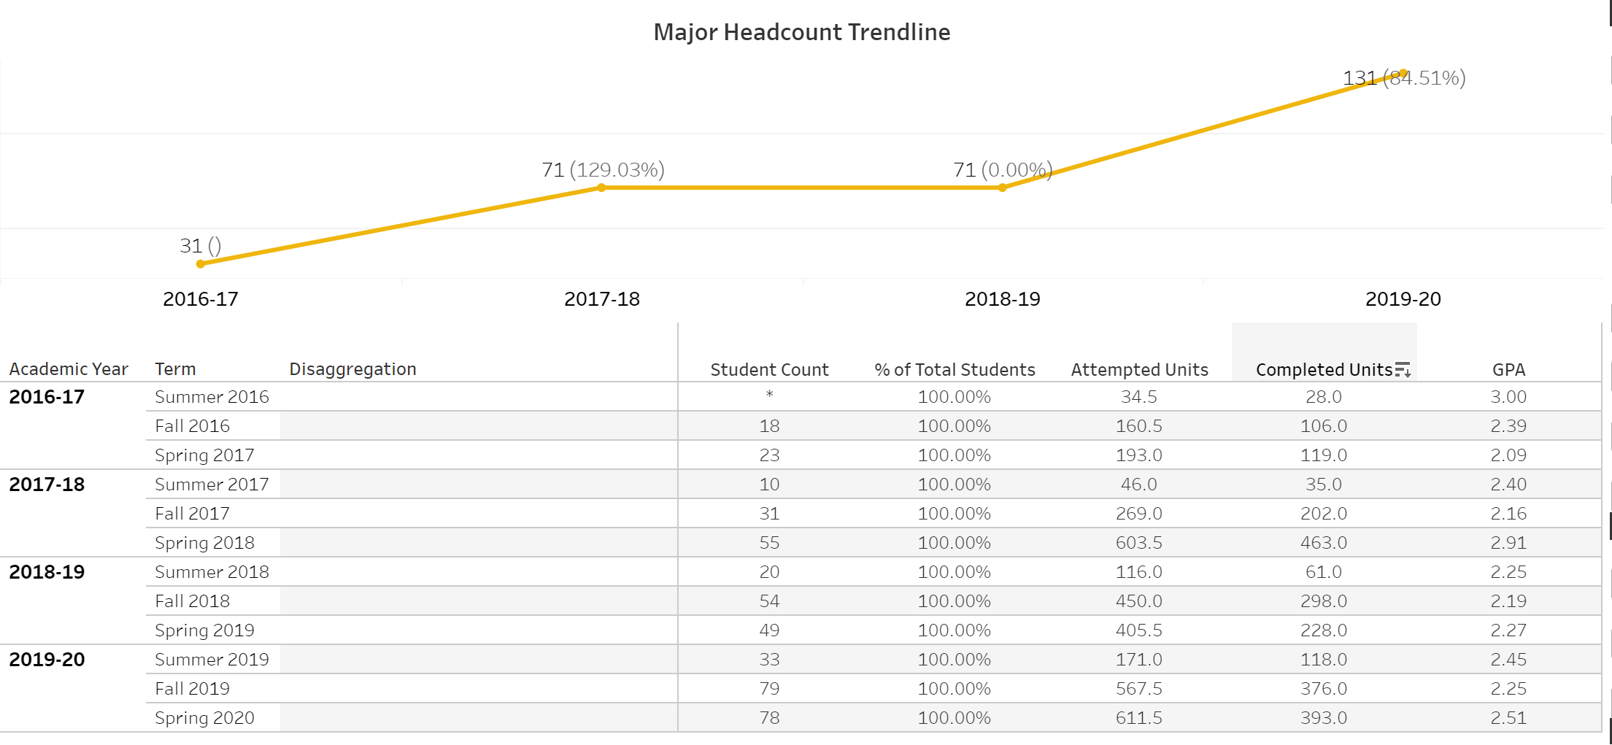
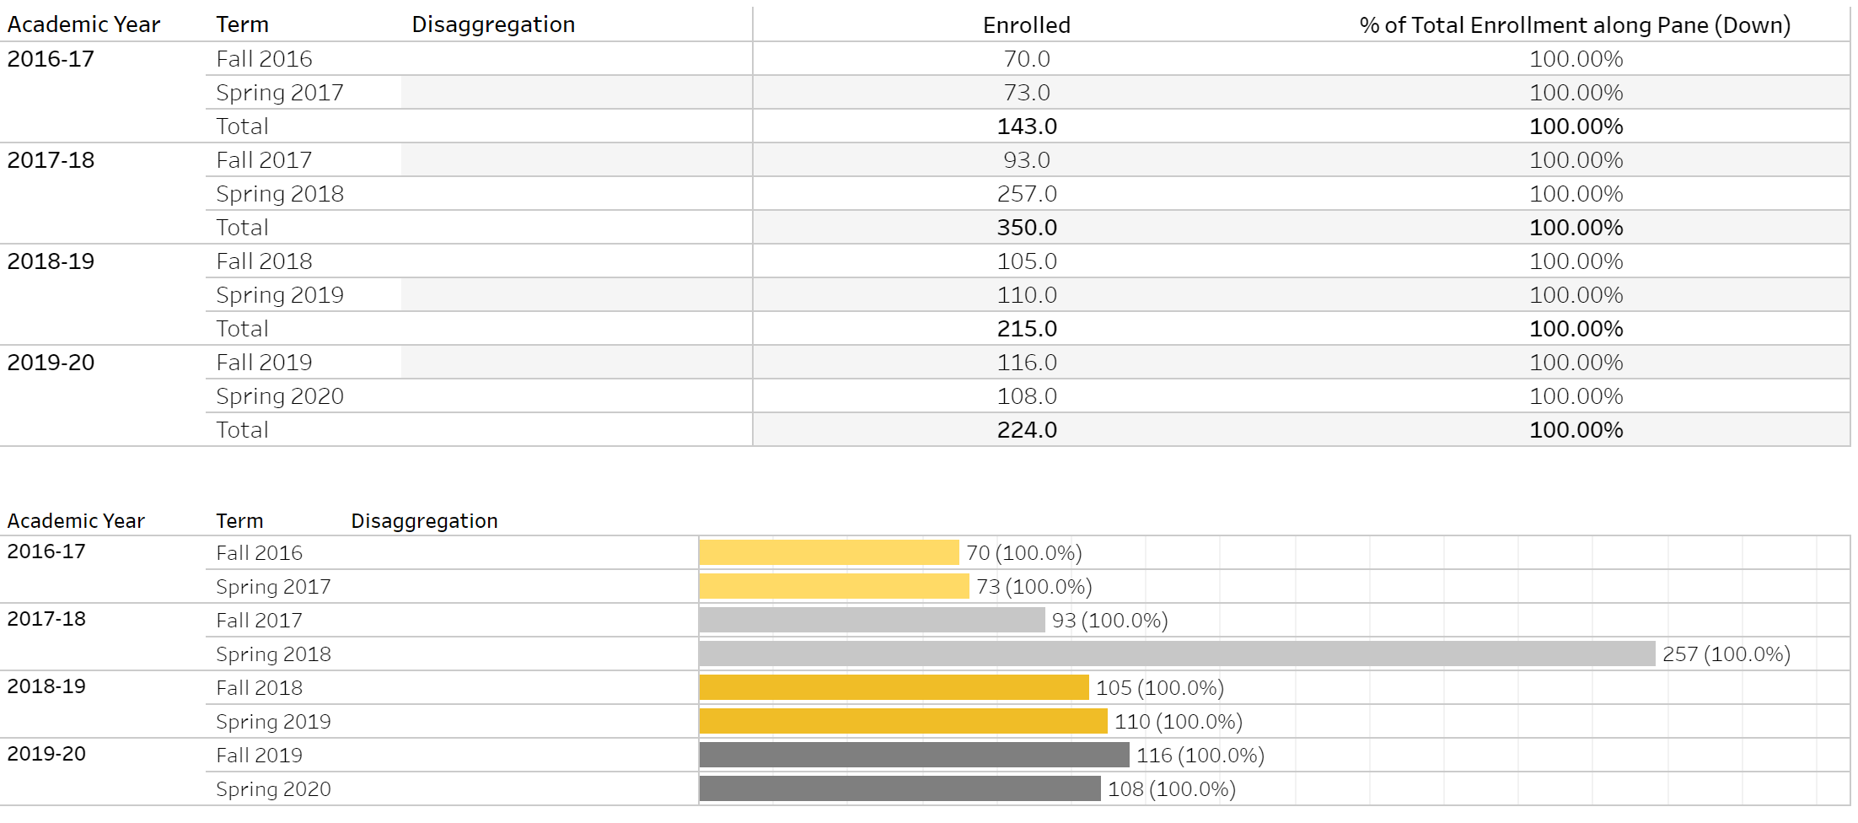
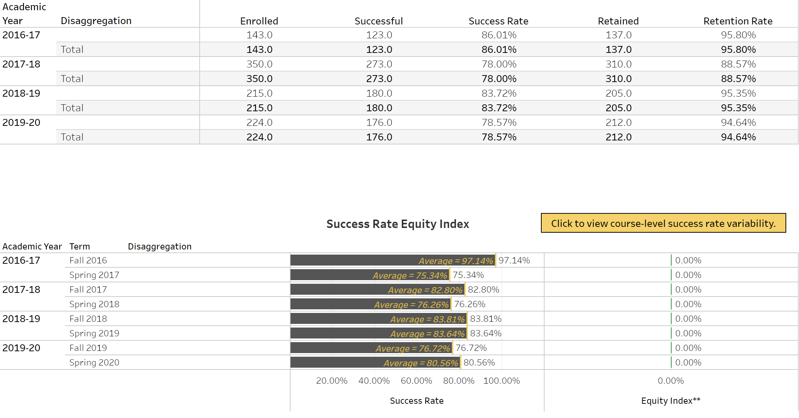
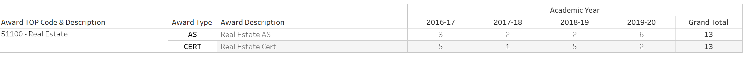
With existing Real Estate program enrollment and completion, as well as declared Real Estate majors, fairly steady or on the rise, this certificate is expected to provide an opportunity for students to earn another award while on their way to completing the existing Real Estate A.S. degree. The stackable nature of this certificate, as well as its online availability, is expected to increase student enrollment and completion.

  - Labor Market Information (LMI)
Summarize the Labor Market Information (LMI) and employment outlook (Including citation for the source of the data) for students exiting the program.
Enter table or chart as a separate attachment.
A labor market analysis completed November 2019 by the Central Valley/Mother Lode Center of Excellence determined that "Based on a comparison of occupational demand and supply, there is an undersupply of 320 trained workers in the subregion and 851 workers in the region" and thus recommended "the expansion of programs to address the shortage of real estate workers in the region."

Similarly, a March 2021 labor market analysis by the Central Valley/Mother Lode Center of Excellence determined that “Based on a comparison of occupational demand and supply, there is an undersupply of 366 trained workers in the subregion and 682 workers in the region. The Center of Excellence recommends that San Joaquin Delta College work with the Business and Entrepreneurship Regional Director, the college’s advisory board, and local industry in the expansion of programs to address the shortage of real estate workers in the region.”

  - Employer Survey (if applicable)
When strong LMI data is not available, an employer survey may be submitted. Provide a copy of the survey, including the number of those surveyed, number of responses, and a summary of the results. The survey must address the extent to which the proposed degree or certificate will be valued by employers.

- Place of Program in Curriculum/Similar Programs
Review the college’s existing program inventory, then address the following questions:
- Do any active inventory records need to be made inactive or changed in connection with the approval or the proposed program? If yes, please specify.
- Does the program replace any existing program(s) on the college’s inventory? Provide relevant details if this program is related to the termination or scaling down of another program(s).
- What related programs are offered by the college?

This program is the initial certificate in a sequence of CTE certificates related to the Real Estate industry. After completing this certificate, students are encouraged to complete the Real Estate Broker Certificate, then the Real Estate A.S. degree. In the future, there may be options to complete a Real Estate Appraiser Certificate and a Real Estate Lending and Mortgage Brokering Certificate.

- Similar Programs at Other Colleges in Service Area
List similar programs offered at other colleges within the Central/Mother Lode Region that may be adversely impacted. Enter ‘none’ if there are no similar programs.
College | Program
Modesto Junior College | Real Estate Sales Skills Recognition Certificate

While a fairly local college is offering a similar certificate, SJDC's program differs in that it is regularly already available entirely online. Further, all courses are already offered at SJDC, so this certificate is simply recognizing students for completing them.

Supporting documentation required

Labor Market Information
In a separate attachment, provide current Labor Market Information showing that jobs are available for program completers within the local service area. Statewide or national LMI may be included as supplementary support but evidence of need in the specific college service area or region is also necessary.

List of Members of Advisory Committee
This list must include advisory committee member names, job titles, and affiliations.
Name | Title | Affiliation
Ed Aguilar | Student Equity & Diversity Manager | San Joaquin Delta College/Higher Education
Ricardo Aguilar | Professor of Spanish and Chair of the SJDCTA Social Justice & Equity Committee | San Joaquin Delta College/Higher Education
Kareem Ali | Teacher | Pacific Law Academy/High School Education
Gus Barrera II | Judge | Superior Court of San Joaquin County/Government
Rick Capello | Principal | Pacific Law Academy/High School Education
Wardell Ron Carter | Investigator | San Joaquin Public Defender's Office/Government
Michelle Castanon | Program Manager, Career Technical Education & Workforce Development | San Joaquin Delta College/Higher Education
Jerome Clay | Attorney and Owner | Law Office of Timothy McCandless and Global One Financial Solutions/Law and Financial Services
Fred Galves | Attorney/Professor of Law | Lincoln Law School/Higher Education
Jonathan Garzoli | Attorney | Garzoli Law Office/Law
Keiland Henderson | Community Engagement Coordinator and Law School Student | City of Stockton and Humphreys College Drivon School of Law/Government and Higher Education
Danell Hepworth | Dean of Applied Science, Business, & Technology | San Joaquin Delta College/Higher Education
Ki Ingersol | Attorney/Counsel | Kroloff, Belcher, Smart, Perry & Christopherson/Law
Akilah Jeffery | Attorney/Teacher/Adjunct | San Joaquin Delta College/Higher Education
Clem Lee | Associate Superintendent | Humphreys College Academy of Business, Law, and Education
Russell Lewis | Teacher and Mock Trial Coach | Stockton Early College Academy
Steven McCarty | Professor of Business Law and Co-Director of the Pathway to Law Program | San Joaquin Delta College/Higher Education
Mario Moreno | Professor of Art | San Joaquin Delta College/Higher Education
La Tasha Mullins | Realtor/Associate | Re/Max/Real Estate
Ron Northup | Judge | Superior Court of San Joaquin County/Government
Robert Oakes | Executive Director | San Joaquin County Bar Association/Law
Cindy Ostberg | Professor of Political Science and Director of the Pacific Legal Scholars Program | University of the Pacific, Pacific Legal Scholars/Higher Education
Matthew Reynolds | Dean of Drivon School of Law | Humphreys University, Drivon School of Law/Higher Education
Toni Robancho | Paralegal | Freeman, D'Aiuto, Pierce, Gurev, Keeling Law Firm and Paralegal Section of the San Joaquin County Bar Association/Law
Monica Sousa | Attorney | California Rural Legal Assistance/Law
Sokun Somsack | Strong Workforce Program Director | San Joaquin Delta College/Higher Education
Shaun Suy | Professor / Counselor | San Joaquin Delta College/Higher Education
David Terry | Professor | San Joaquin Delta College/Higher Education
Lisa Aguilera Lawrenson | Interim Assistant Superintendent / Vice President of Instruction and Planning | San Joaquin Delta College/Higher Education
Michele Valeros | Investigative Assistant II | San Joaquin County District Attorney’s Office/Government
Max Vargas | Senior Policy Advisor to Mayor Michael Tubbs | City of Stockton/Government
Salvador Vargas | Dean of CTE & Workforce Development | San Joaquin Delta College/Higher Education
Martha Villarreal | Professor of Business and Former Acting Dean of Regional and Distance Education | San Joaquin Delta College/Higher Education
Evan Wade | Professor of History | San Joaquin Delta College/Higher EducationProfessor of Business and Former Acting Dean of Regional and Distance Education

Recommendation of Advisory Committee (Meeting Minutes)
In a separate attachment, provide minutes of the advisory committee meetings at which the program was discussed and approved, with relevant areas highlighted, as well as a summary of the advisory committee recommendations.
According to the minutes, "Johnathan Cardiel made a motion that Steven McCarty move forward with the two separate but stackable certificates once the smaller certificate meets the financial aid criteria. Alicia Stewart seconded the motion. There were no objections and the ayes carried the motion unanimously."

